^{Social Media Post Copy}
^{Image} | ^{Post Copy}
 | We are now offering easy [ordering/pickup/delivery] for your convenience! Give us a call at [practice phone number/ or visit practice website] to order your Bausch + Lomb contact lenses. Stock up today! #InThisTogether #BauschandLombStrong
Experience all day comfort from home. We are now offering easy [ordering/pickup/delivery] for your convenience!
Contact us at [practice phone number/ or visit practice website] to order your Bausch + Lomb contact lenses.
#InThisTogether #BauschandLombStrong
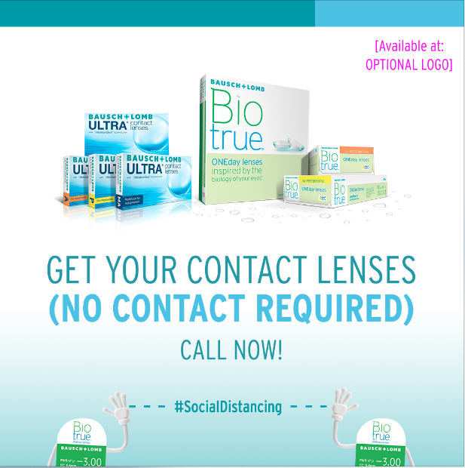 | Practicing your Social Distancing? We now offer easy [ordering/pickup/delivery] for your convenience!  Call at [practice phone number/ or visit practice website] to order your  Bausch + Lomb contact lenses now.  #InThisTogether #BauschandLombStrong
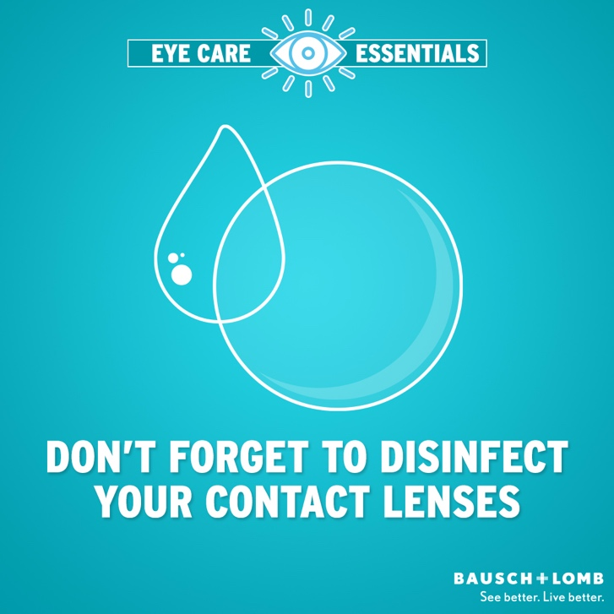 | Eye Care Tip #1- Don’t forget to disinfect your contact lenses as recommended by [Doctor’s name]. Call us at [practice phone number/ or visit practice website] with any eye-related issues, questions or concerns.  Learn more about contact lens care at: https://www.bausch.com/your-eye-concerns/wearing-contact-lenses/wearing-and-caring-for-contact-lenses
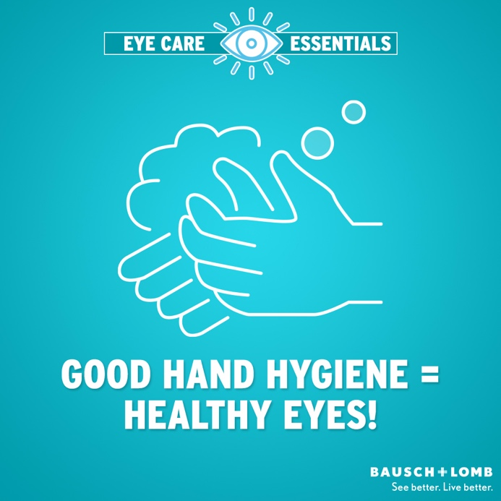 | Eye Care Tip #2- Keep your eyes healthy! Wash, rinse, and dry your hands thoroughly before touching your contact lenses. If you have questions or concerns, give us a call at [practice phone number/ or visit practice website] to book an appointment.  Learn more about eye care at: https://www.bausch.com/your-eye-concerns/wearing-contact-lenses/wearing-and-caring-for-contact-lenses
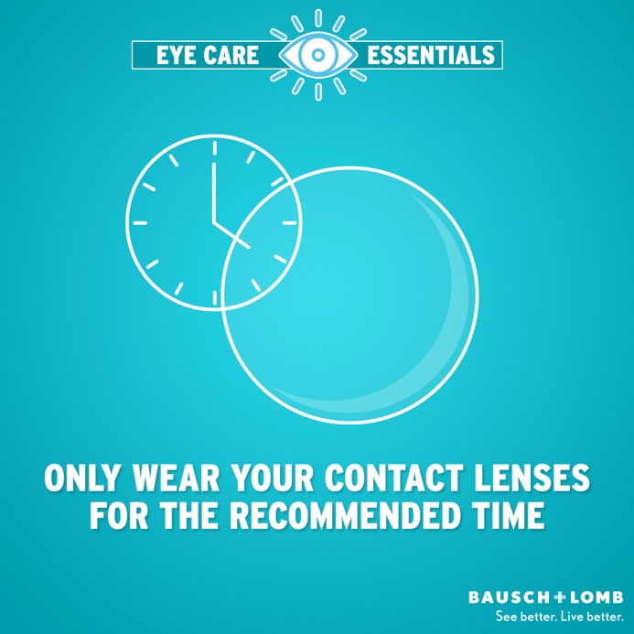 | Eye Care Tip #3 – For best performance, only wear your contact lenses for the time recommended by [Doctor’s name]. Call us at [practice phone number] with any questions or concerns.  Learn more about contact lens wear at: https://www.bausch.com/our-products/contact-lenses/successful-contact-lens-wear/dv-p

BAUSCH + LOMB, Biotrue, inspired by the biology of your eyes, Bausch + Lomb ULTRA, MoistureSeal and the drop design are trademarks of Bausch & Lomb Incorporated or its affiliates. Any other product/brand names and/or logos are trademarks of the respective owners.
© 2020 Bausch & Lomb Incorporated or its affiliates. VCCM.0077.USA.20

